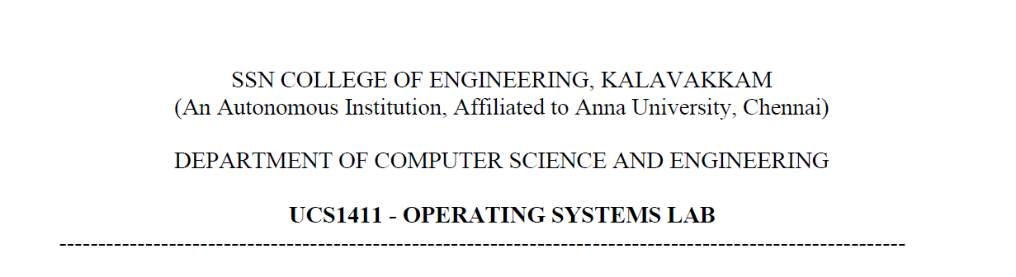

UCS1412 – DBMS Lab

Assignment – 1

Name: Jayannthan P T

Dept: CSE ‘A’

Roll No.: 205001049

**Title:** DDL for Mail Order Database

**Schema Diagram:**

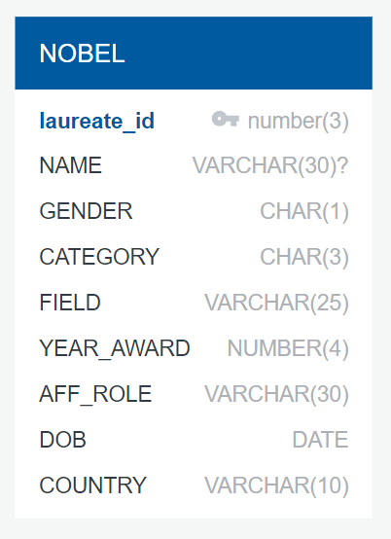

**Observation Index Correction:**

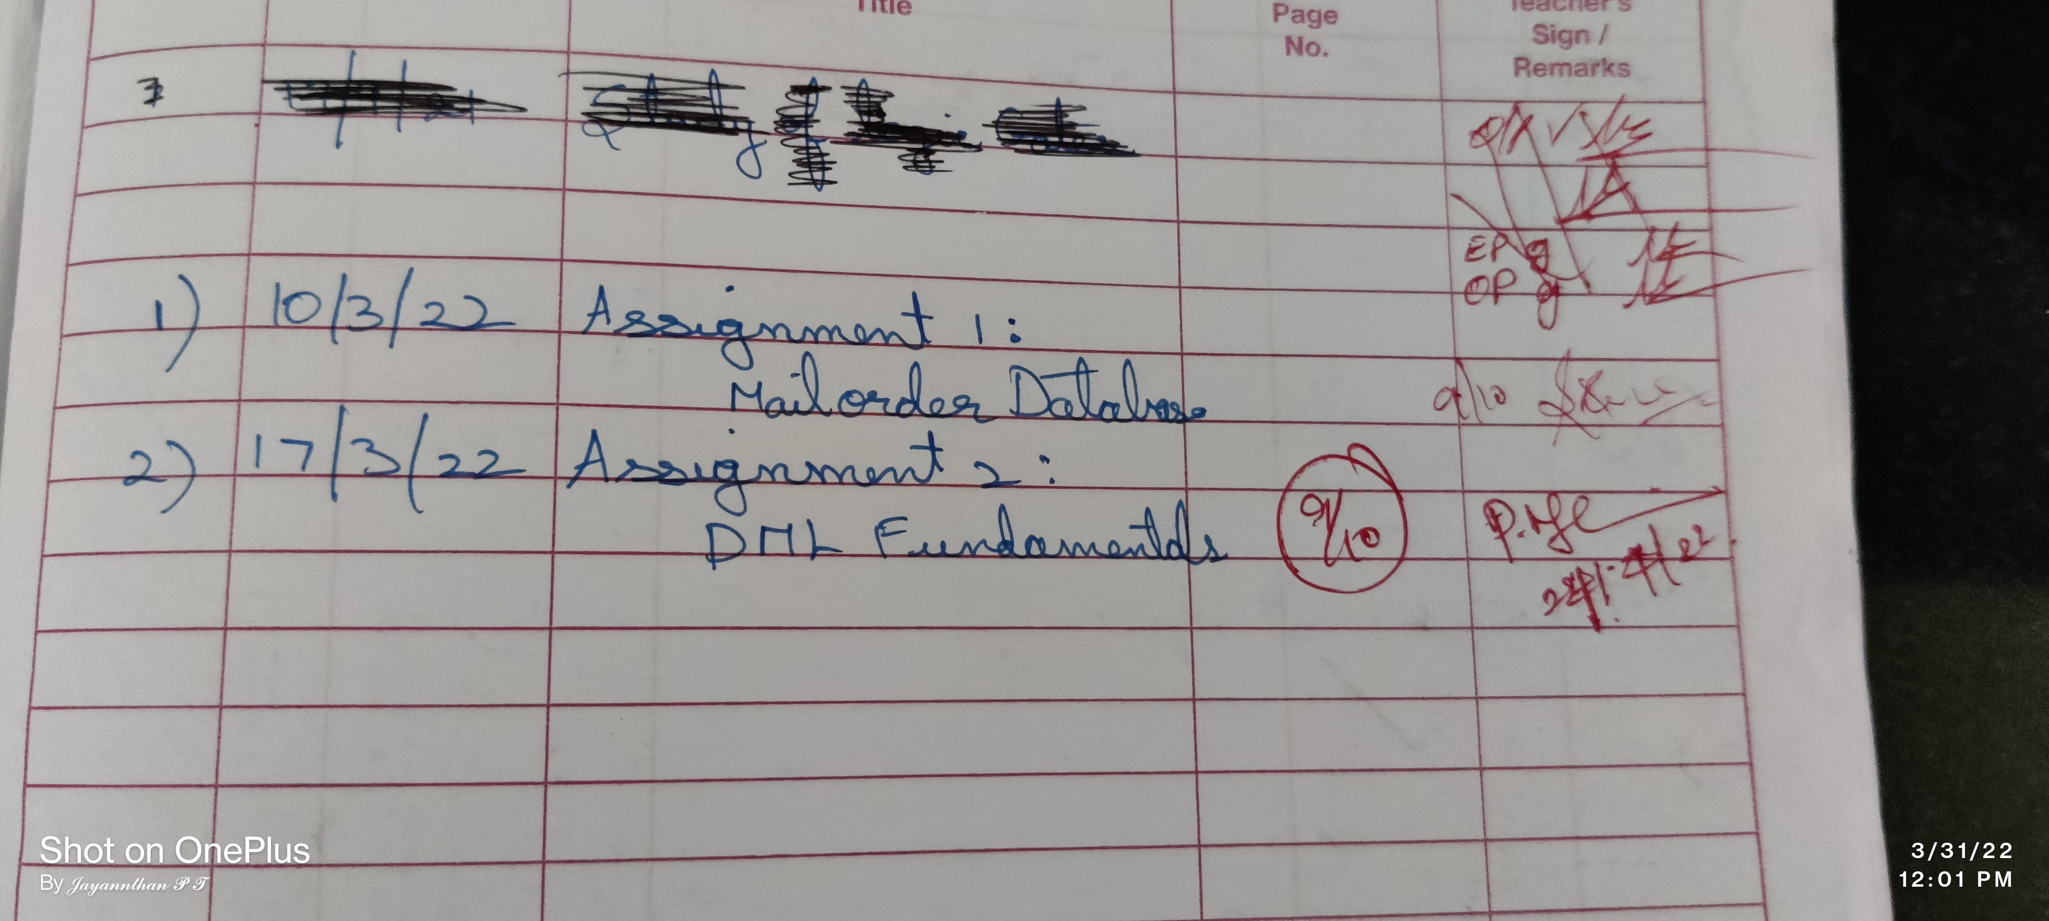

**Spool File Output:**

SQL> *-- Write DML queries for the following:*

SQL>

SQL> *--1.Display the nobel laureate(s) who born after 1-Jul-1960.*

SQL> SELECT *

  2  FROM NOBEL

  3  WHERE DOB >('1-Jul-1960');

LAUREATE_ID NAME                           G CAT FIELD

*----------- ------------------------------ - --- -------------------------*

YEAR_AWARD AFF_ROLE                       DOB       COUNTRY

*---------- ------------------------------ --------- ----------*

        111 Eric A Cornell                 m Phy Atomic physics

      2001 University of Colorado         19-DEC-61 USA

        124 Carol W Greider                f Med Enzymes

      2009 Johns Hopkins University       15-APR-61 USA

        125 Barack H Obama                 m Pea World organizing

      2009 President of USA               04-AUG-61 USA

SQL>

SQL> *--2. Display the Indian laureate (name, category, field, country, year awarded) who was awarded in the Chemistry category.*

SQL> SELECT NAME, CATEGORY, FIELD, COUNTRY, YEAR_AWARD

  2  FROM NOBEL

  3  WHERE COUNTRY='India' AND CATEGORY='Che';

NAME                           CAT FIELD                     COUNTRY

*------------------------------ --- ------------------------- ----------*

YEAR_AWARD

*----------*

Venkatraman Ramakrishnan       Che Biochemistry              India

      2009

SQL>

SQL> *-- 3. Display the laureates (name, category,field and year of award) who was awarded between 2000 and 2005 for the Physics or Chemistry category.*

SQL> SELECT NAME, CATEGORY, FIELD, YEAR_AWARD

  2  FROM NOBEL

  3  WHERE (YEAR_AWARD BETWEEN 2001 AND 2005) AND (CATEGORY='Che' OR CATEGORY='Phy');

NAME                           CAT FIELD                     YEAR_AWARD

*------------------------------ --- ------------------------- ----------*

Eric A Cornell                 Phy Atomic physics                  2001

Carl E Wieman                  Phy Atomic physics                  2001

Ryoji Noyori                   Che Organic Chemistry               2001

K Barry Sharpless              Che Organic Chemistry               2001

SQL>

SQL> *-- 4. Display the laureates name with their age at the time of award for the Peace category.*

SQL> SELECT NAME, YEAR_AWARD-EXTRACT(YEAR FROM DOB) AS AGE, YEAR_AWARD

  2  FROM NOBEL

  3  WHERE CATEGORY='Pea';

NAME                                  AGE YEAR_AWARD

*------------------------------ ---------- ----------*

John Hume                              61       1998

David Trimble                          54       1998

Kofi Annan                             63       2001

Barack H Obama                         48       2009

SQL>

SQL> *-- 5. Display the laureates (name,category,aff_role,country) whose name starts with A or ends with a, but not from Isreal.*

SQL> SELECT NAME, CATEGORY, AFF_ROLE, COUNTRY

  2  FROM NOBEL

  3  WHERE (NAME LIKE 'A%' OR NAME LIKE '%a') AND COUNTRY <> 'Isreal';

NAME                           CAT AFF_ROLE                       COUNTRY

*------------------------------ --- ------------------------------ ----------*

Amartya Sen                    Eco Trinity College                India

Barack H Obama                 Pea President of USA               USA

SQL>

SQL> *-- 6. Display the name, gender, affiliation, dob and country of laureates who was born in 1950's. Label the dob column as Born 1950.*

SQL> SELECT NAME, GENDER, AFF_ROLE, DOB AS BORN1950, COUNTRY

  2  FROM NOBEL

  3  WHERE DOB >('1-Jan-1950') AND DOB < ('31-Dec-1959');

NAME                           G AFF_ROLE                       BORN1950

*------------------------------ - ------------------------------ ---------*

COUNTRY

*----------*

Robert B. Laughlin             m Stanford University            01-NOV-50

USA

Carl E Wieman                  m University of Colorado         26-MAR-51

USA

Venkatraman Ramakrishnan       m MRC Laboratory                 19-AUG-52

India

NAME                           G AFF_ROLE                       BORN1950

*------------------------------ - ------------------------------ ---------*

COUNTRY

*----------*

Herta Muller                   f                                17-AUG-53

Romania

SQL>

SQL>

SQL> *-- 7. Display the laureates (name,gender,category,aff_role,country) whose name starts with A, D or H. Remove the laureate if he/she do not have any affiliation. Sort the results in ascending order of name.*

SQL> SELECT NAME, GENDER, CATEGORY, AFF_ROLE, COUNTRY

  2  FROM NOBEL

  3  WHERE (NAME LIKE 'A%' OR NAME LIKE 'D%' OR NAME LIKE 'H%') AND AFF_ROLE IS NOT NULL

  4  ORDER BY NAME;

NAME                           G CAT AFF_ROLE                       COUNTRY

*------------------------------ - --- ------------------------------ ----------*

Ada E Yonath                   f Che Weizmann Institute of Science  Isreal

Amartya Sen                    m Eco Trinity College                India

Daniel C. Tsui                 m Phy Princeton University           China

David Trimble                  m Pea Ulster Unionist party Leader   Ireland

Horst L Stormer                m Phy Columbia University            Germany

SQL>

SQL> *-- 8. Display the university name(s) that has to its credit by having at least 2 nobel laureate with them.*

SQL> SELECT AFF_ROLE

  2  FROM NOBEL

  3  GROUP BY AFF_ROLE

  4  HAVING COUNT(AFF_ROLE) > 1;

AFF_ROLE

*------------------------------*

Bell Laboratories

University of California

University of Colorado

SQL>

SQL> *-- 9. List the date of birth of youngest and eldest laureates by countrywise. Label the column as Younger, Elder respectively. Include only the country having more than one laureate. Sort the output in alphabetical order of country.*

SQL> SELECT COUNTRY, MAX(DOB) AS YOUNGEST, MIN(DOB) AS ELDEST

  2  FROM NOBEL

  3  GROUP BY COUNTRY

  4  HAVING (COUNT(COUNTRY) >= 2 )

  5  ORDER BY COUNTRY;

COUNTRY    YOUNGEST  ELDEST

*---------- --------- ---------*

China      28-FEB-39 04-NOV-33

India      19-AUG-52 03-NOV-33

Ireland    15-OCT-44 18-JAN-37

UK         17-AUG-32 31-OCT-25

USA        19-DEC-61 10-MAY-30

SQL>

SQL>

SQL> *-- 10. Show the details (year award,category,field) where the award is shared among the laureates in the same category and field. Exclude the laureates from USA.*

SQL> SELECT CATEGORY, FIELD, YEAR_AWARD

  2  FROM NOBEL

  3  WHERE COUNTRY <> 'USA'

  4  GROUP BY FIELD,CATEGORY,YEAR_AWARD

  5  HAVING(COUNT(*) >= 2);

CAT FIELD                     YEAR_AWARD

*--- ------------------------- ----------*

Phy Condensed matter                1998

Che Theoretical Chemistry           1998

Pea Negotiation                     1998

Che Biochemistry                    2009

SQL>

SQL>

SQL> *-- Use TCL Statements*

SQL>

SQL> *-- 11.Mark an intermediate point in the transaction (savepoint)*

SQL> SAVEPOINT

  2  save;

Savepoint created.

SQL>

SQL> *-- 12.Insert a new tuple into the nobel relation*

SQL> INSERT INTO NOBEL

  2  VALUES(129, 'Tony Stark', 'm', 'Phy', 'Physics', 2021, '', '17-DEC-1989', 'USA');

1 row created.

SQL> *-- printing updated table*

SQL> SELECT *

  2  FROM NOBEL

  3  WHERE NAME='Tony Stark';

LAUREATE_ID NAME                           G CAT FIELD

*----------- ------------------------------ - --- -------------------------*

YEAR_AWARD AFF_ROLE                       DOB       COUNTRY

*---------- ------------------------------ --------- ----------*

        129 Tony Stark                     m Phy Physics

      2021                                17-DEC-89 USA

SQL>

SQL> *-- 13.Update the aff_role of literature laureates as 'Linguists'.*

SQL>

SQL> SELECT *

  2  FROM NOBEL

  3  WHERE CATEGORY='Lit';

LAUREATE_ID NAME                           G CAT FIELD

*----------- ------------------------------ - --- -------------------------*

YEAR_AWARD AFF_ROLE                       DOB       COUNTRY

*---------- ------------------------------ --------- ----------*

        110 Jose Saramago                  m Lit Portuguese

      1998                                16-NOV-22 Portugal

        117 V S Naipaul                    m Lit English

      2001                                17-AUG-32 UK

        128 Herta Muller                   f Lit German

      2009                                17-AUG-53 Romania

SQL>

SQL> UPDATE NOBEL SET aff_role='Linguists' WHERE CATEGORY='Lit';

3 rows updated.

SQL>

SQL> *-- printing updated table*

SQL> SELECT *

  2  FROM NOBEL

  3  WHERE CATEGORY='Lit';

LAUREATE_ID NAME                           G CAT FIELD

*----------- ------------------------------ - --- -------------------------*

YEAR_AWARD AFF_ROLE                       DOB       COUNTRY

*---------- ------------------------------ --------- ----------*

        110 Jose Saramago                  m Lit Portuguese

      1998 Linguists                      16-NOV-22 Portugal

        117 V S Naipaul                    m Lit English

      2001 Linguists                      17-AUG-32 UK

        128 Herta Muller                   f Lit German

      2009 Linguists                      17-AUG-53 Romania

SQL> SELECT *

  2  FROM NOBEL;

LAUREATE_ID NAME                           G CAT FIELD

*----------- ------------------------------ - --- -------------------------*

YEAR_AWARD AFF_ROLE                       DOB       COUNTRY

*---------- ------------------------------ --------- ----------*

        100 Robert B. Laughlin             m Phy Condensed matter

      1998 Stanford University            01-NOV-50 USA

        101 Horst L Stormer                m Phy Condensed matter

      1998 Columbia University            06-APR-49 Germany

        102 Daniel C. Tsui                 m Phy Condensed matter

      1998 Princeton University           28-FEB-39 China

LAUREATE_ID NAME                           G CAT FIELD

*----------- ------------------------------ - --- -------------------------*

YEAR_AWARD AFF_ROLE                       DOB       COUNTRY

*---------- ------------------------------ --------- ----------*

        103 Walter Kohn                    m Che Theoretical Chemistry

      1998 University of California       09-MAR-23 Austria

        104 John Pople                     m Che Theoretical Chemistry

      1998 North Western University       31-OCT-25 UK

        106 John Hume                      m Pea Negotiation

      1998 Labour party Leader            18-JAN-37 Ireland

LAUREATE_ID NAME                           G CAT FIELD

*----------- ------------------------------ - --- -------------------------*

YEAR_AWARD AFF_ROLE                       DOB       COUNTRY

*---------- ------------------------------ --------- ----------*

        107 David Trimble                  m Pea Negotiation

      1998 Ulster Unionist party Leader   15-OCT-44 Ireland

        108 Louis J Ignaroo                m Med Cardiovascular system

      1998 University of California       31-MAY-41 USA

        109 Amartya Sen                    m Eco Welfare Economics

      1998 Trinity College                03-NOV-33 India

LAUREATE_ID NAME                           G CAT FIELD

*----------- ------------------------------ - --- -------------------------*

YEAR_AWARD AFF_ROLE                       DOB       COUNTRY

*---------- ------------------------------ --------- ----------*

        110 Jose Saramago                  m Lit Portuguese

      1998 Linguists                      16-NOV-22 Portugal

        111 Eric A Cornell                 m Phy Atomic physics

      2001 University of Colorado         19-DEC-61 USA

        112 Carl E Wieman                  m Phy Atomic physics

      2001 University of Colorado         26-MAR-51 USA

LAUREATE_ID NAME                           G CAT FIELD

*----------- ------------------------------ - --- -------------------------*

YEAR_AWARD AFF_ROLE                       DOB       COUNTRY

*---------- ------------------------------ --------- ----------*

        113 Ryoji Noyori                   m Che Organic Chemistry

      2001 Nagoya University              03-SEP-38 Japan

        114 K Barry Sharpless              m Che Organic Chemistry

      2001 Scripps Research Institute     28-APR-41 USA

        115 Kofi Annan                     m Pea World organizing

      2001 UN General                     08-APR-38 Ghana

LAUREATE_ID NAME                           G CAT FIELD

*----------- ------------------------------ - --- -------------------------*

YEAR_AWARD AFF_ROLE                       DOB       COUNTRY

*---------- ------------------------------ --------- ----------*

        116 Joerge A Akeriof               m Eco Economic of Information

      2001 University of California       17-JUN-40 USA

        117 V S Naipaul                    m Lit English

      2001 Linguists                      17-AUG-32 UK

        118 Charles A Kao                  m Phy Fiber technology

      2009 University of Hongkong         04-NOV-33 China

LAUREATE_ID NAME                           G CAT FIELD

*----------- ------------------------------ - --- -------------------------*

YEAR_AWARD AFF_ROLE                       DOB       COUNTRY

*---------- ------------------------------ --------- ----------*

        119 Willard S Boyle                m Phy Semiconductor technology

      2009 Bell Laboratories              19-AUG-24 Canada

        120 George E Smith                 m Phy Semiconductor technology

      2009 Bell Laboratories              10-MAY-30 USA

        121 Venkatraman Ramakrishnan       m Che Biochemistry

      2009 MRC Laboratory                 19-AUG-52 India

LAUREATE_ID NAME                           G CAT FIELD

*----------- ------------------------------ - --- -------------------------*

YEAR_AWARD AFF_ROLE                       DOB       COUNTRY

*---------- ------------------------------ --------- ----------*

        122 Ada E Yonath                   f Che Biochemistry

      2009 Weizmann Institute of Science  22-JUN-39 Isreal

        123 Elizabeth H Blackburn          f Med Enzymes

      2009 University of California       26-NOV-48 Australia

        124 Carol W Greider                f Med Enzymes

      2009 Johns Hopkins University       15-APR-61 USA

LAUREATE_ID NAME                           G CAT FIELD

*----------- ------------------------------ - --- -------------------------*

YEAR_AWARD AFF_ROLE                       DOB       COUNTRY

*---------- ------------------------------ --------- ----------*

        125 Barack H Obama                 m Pea World organizing

      2009 President of USA               04-AUG-61 USA

        126 Oliver E Williamson            m Eco Economic governance

      2009 University of California       27-SEP-32 USA

        127 Elinor Ostrom                  m Eco Economic governance

      2009 Indiana University             07-AUG-33 USA

LAUREATE_ID NAME                           G CAT FIELD

*----------- ------------------------------ - --- -------------------------*

YEAR_AWARD AFF_ROLE                       DOB       COUNTRY

*---------- ------------------------------ --------- ----------*

        128 Herta Muller                   f Lit German

      2009 Linguists                      17-AUG-53 Romania

        129 Tony Stark                     m Phy Physics

      2021                                17-DEC-89 USA

29 rows selected.

SQL>

SQL> *-- 14.Delete the laureate(s) who was awarded in Enzymes field*

SQL> SELECT *

  2  FROM NOBEL

  3  WHERE FIELD='Enzymes';

LAUREATE_ID NAME                           G CAT FIELD

*----------- ------------------------------ - --- -------------------------*

YEAR_AWARD AFF_ROLE                       DOB       COUNTRY

*---------- ------------------------------ --------- ----------*

        123 Elizabeth H Blackburn          f Med Enzymes

      2009 University of California       26-NOV-48 Australia

        124 Carol W Greider                f Med Enzymes

      2009 Johns Hopkins University       15-APR-61 USA

SQL>

SQL> DELETE FROM NOBEL

  2  WHERE FIELD='Enzymes';

2 rows deleted.

SQL>

SQL> *-- printing updated table*

SQL> SELECT *

  2  FROM NOBEL

  3  WHERE FIELD='Enzymes';

no rows selected

SQL>

SQL> *-- 15.Discard the most recent update operations (rollback)*

SQL>

SQL> ROLLBACK

  2  TO

  3  save;

Rollback complete.

SQL>

SQL> *-- printing table after rollback*

SQL> SELECT *

  2  FROM NOBEL

  3  WHERE FIELD='Enzymes';

LAUREATE_ID NAME                           G CAT FIELD

*----------- ------------------------------ - --- -------------------------*

YEAR_AWARD AFF_ROLE                       DOB       COUNTRY

*---------- ------------------------------ --------- ----------*

        123 Elizabeth H Blackburn          f Med Enzymes

      2009 University of California       26-NOV-48 Australia

        124 Carol W Greider                f Med Enzymes

      2009 Johns Hopkins University       15-APR-61 USA

SQL>

SQL>

SQL> *-- 16.Commit the changes*

SQL> Commit;

Commit complete.

SQL> spool off